HOW TO SIGN TO AWS ACCOUNT AND HOW TO CREATE INSTACE

Step 1: Go to AWS Console
Open a web browser and navigate to the AWS Management Console homepage.
URL: https://aws.amazon.com/console/
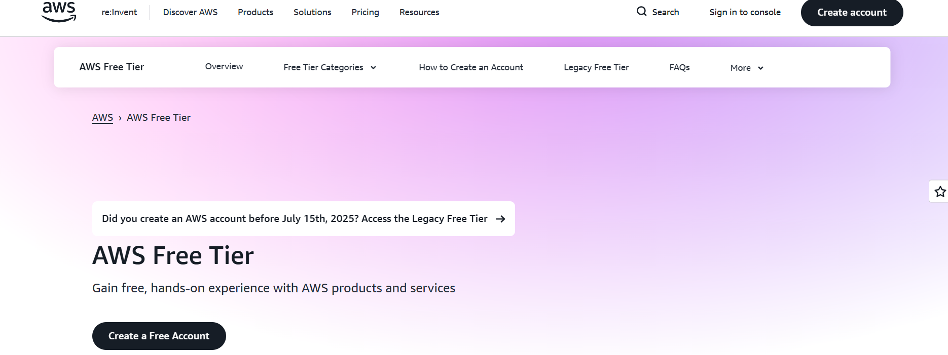

Step 2: Sign in to AWS Console
Here we used to give user name and password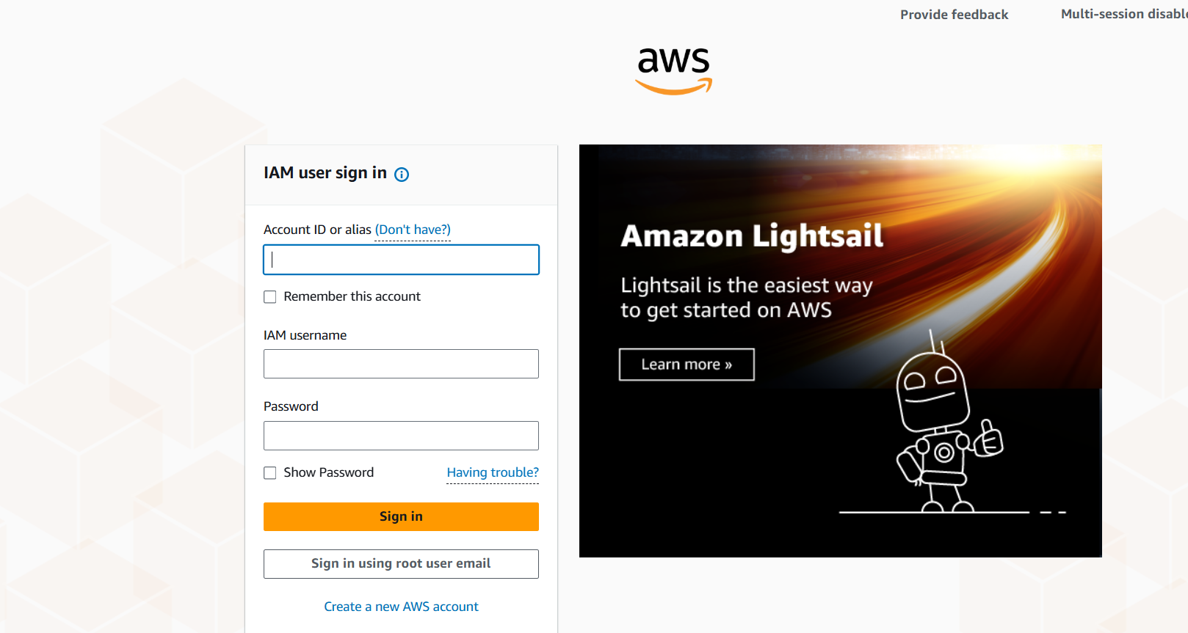

Step 3: Sign to Root user
- Here I am login with only with Email authidication to sign in.
- If applicable, complete Multi-Factor Authentication (MFA) for security to login only root user .

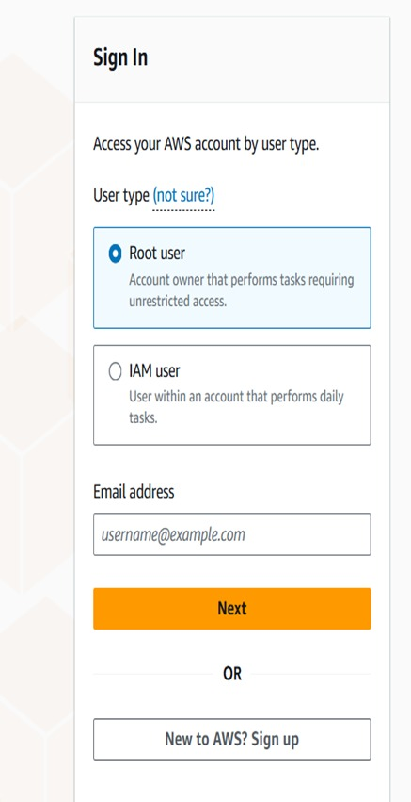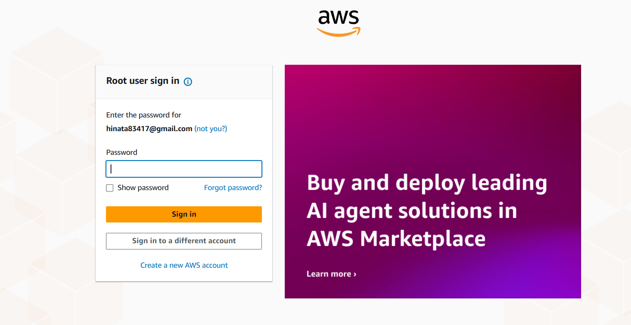Step 4: console page
- I this console page page I can see overall cluster detils like ec2 insatnce and rds s3 buket netowrking what and all you acces the server details we are creating here
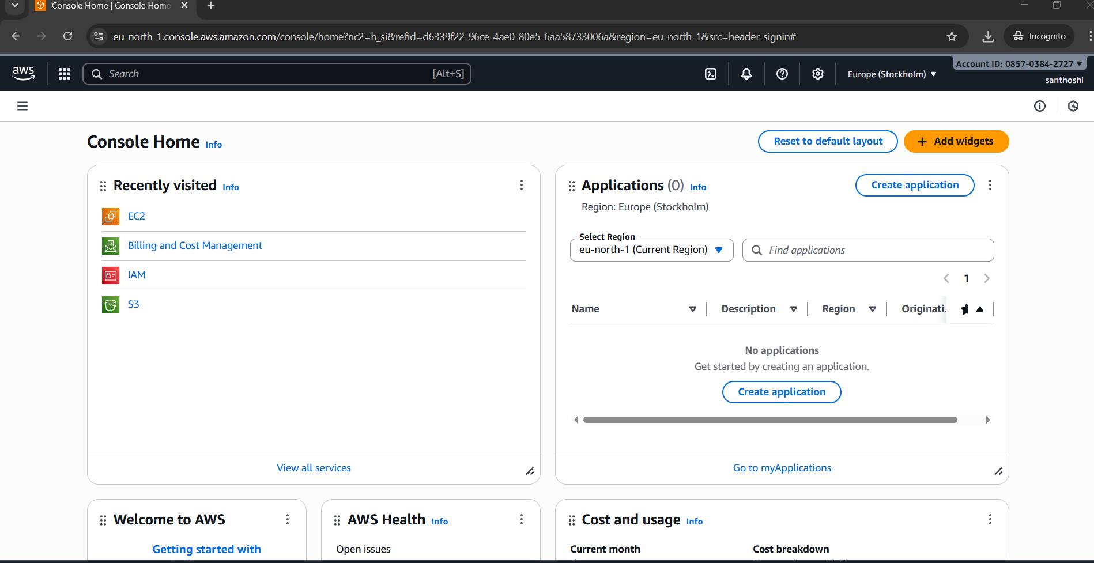
Step 5: access to ec2 insatance
- Here in search bar I am seleccting ec2 we can see ec2 --- click on EC2 then it will nagivate to creation server instane page .
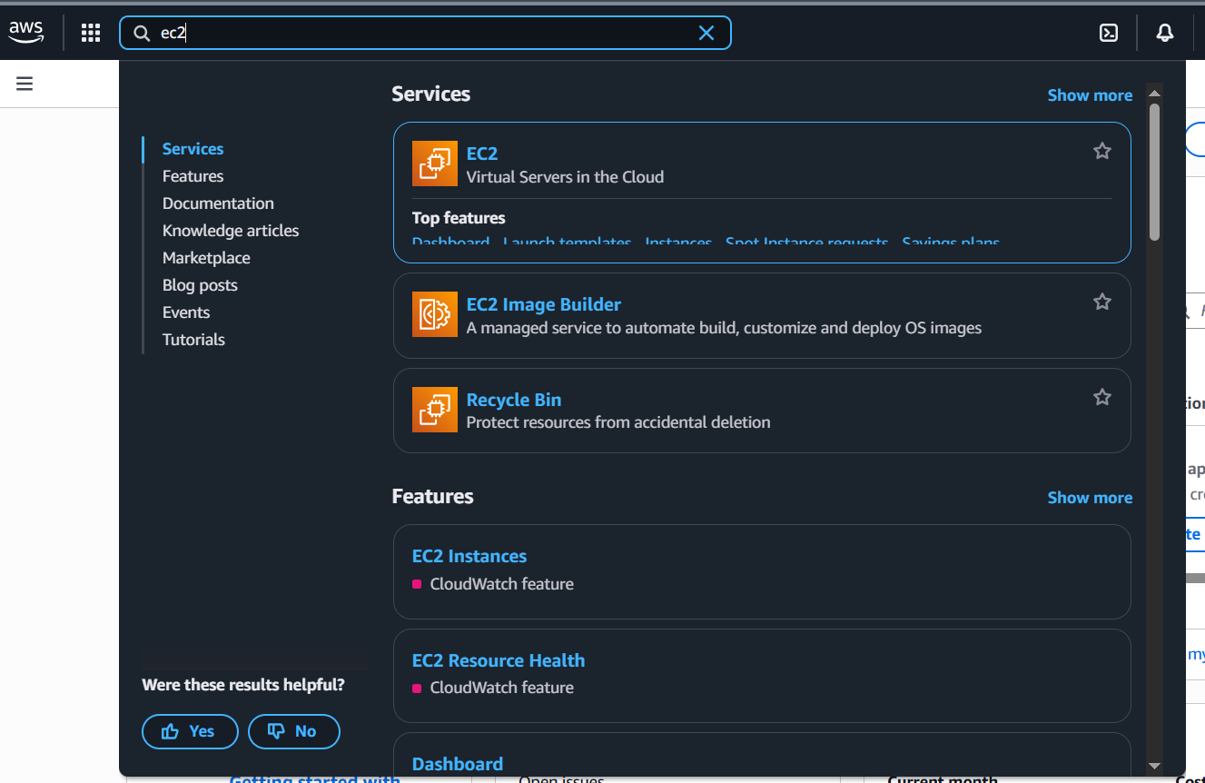
STEP6: click on Launch Instances
- Then after we are going to launch the instance
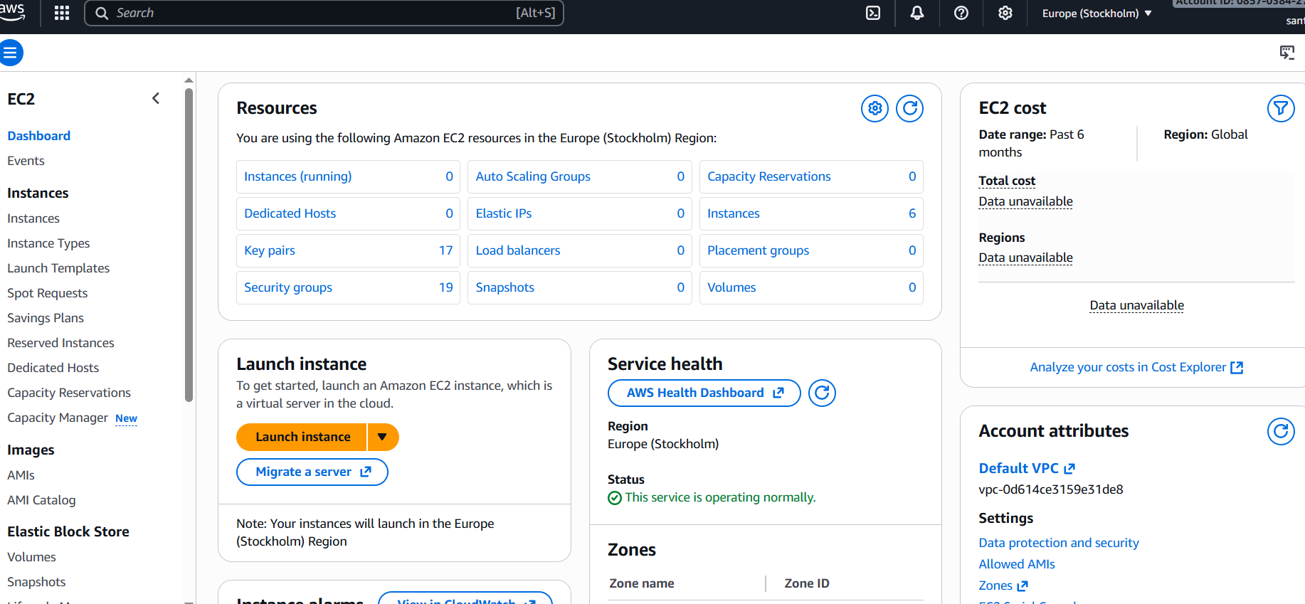

Creation process of instance
Step 7: Naming of server
when we are going to launch the instance after that it will show the name and tags in that we have mention one any Name as you wish
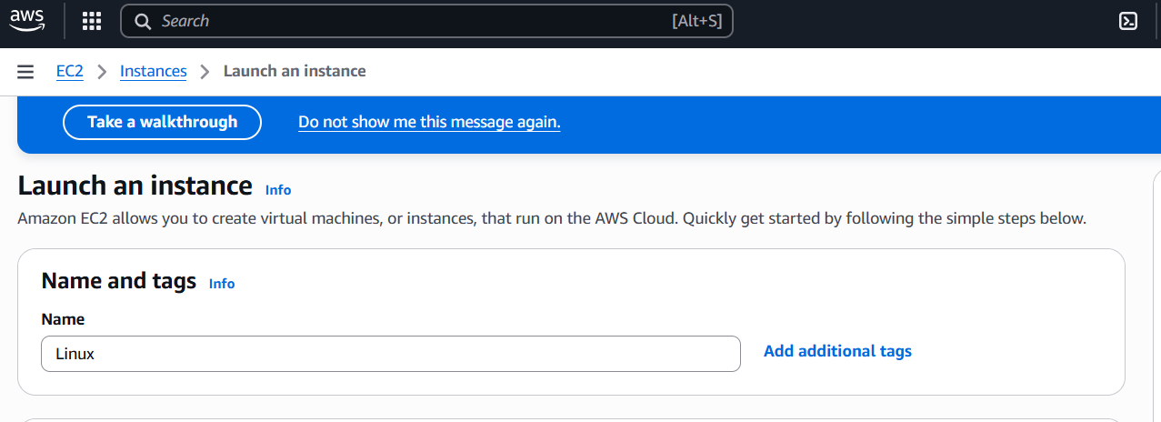
STEP 8: selection distrubution flovours
- They are the different types of operating systems in that we are going to use the ubuntu here Ubuntu is a free and open-source operating system based on the Linux kernel .
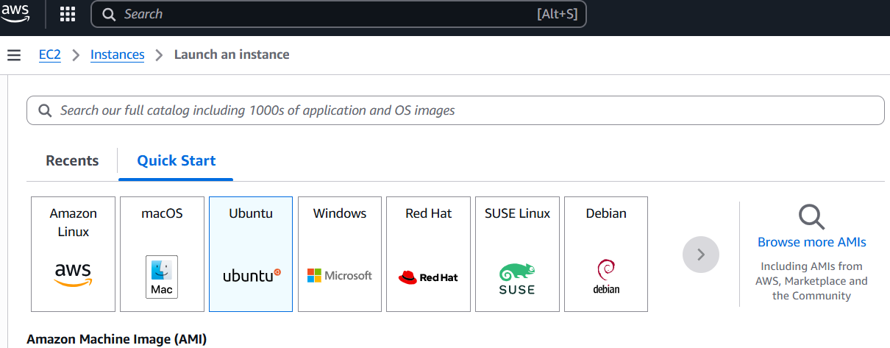

STEP 9: choosing cpu & memory utilization of server
- Then after selecting the Ubuntu we have select the instance type as free trail eligible
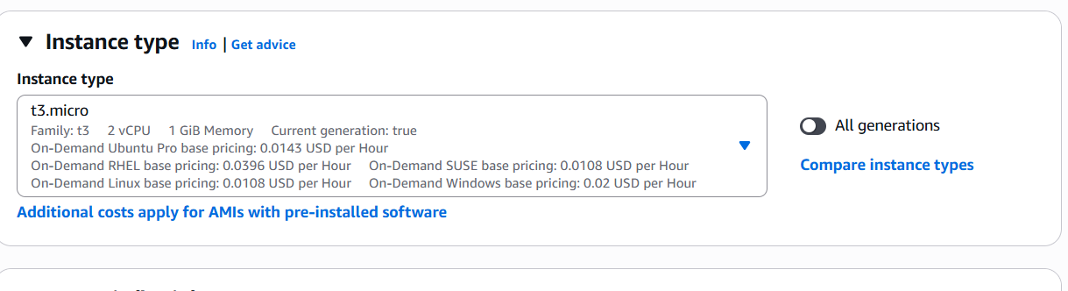
STEP10: creating of security groups to allow the port numbers to acces the application
- A network is a group of interconnected devices that can communicate and share resources, like computers, printers, or phones .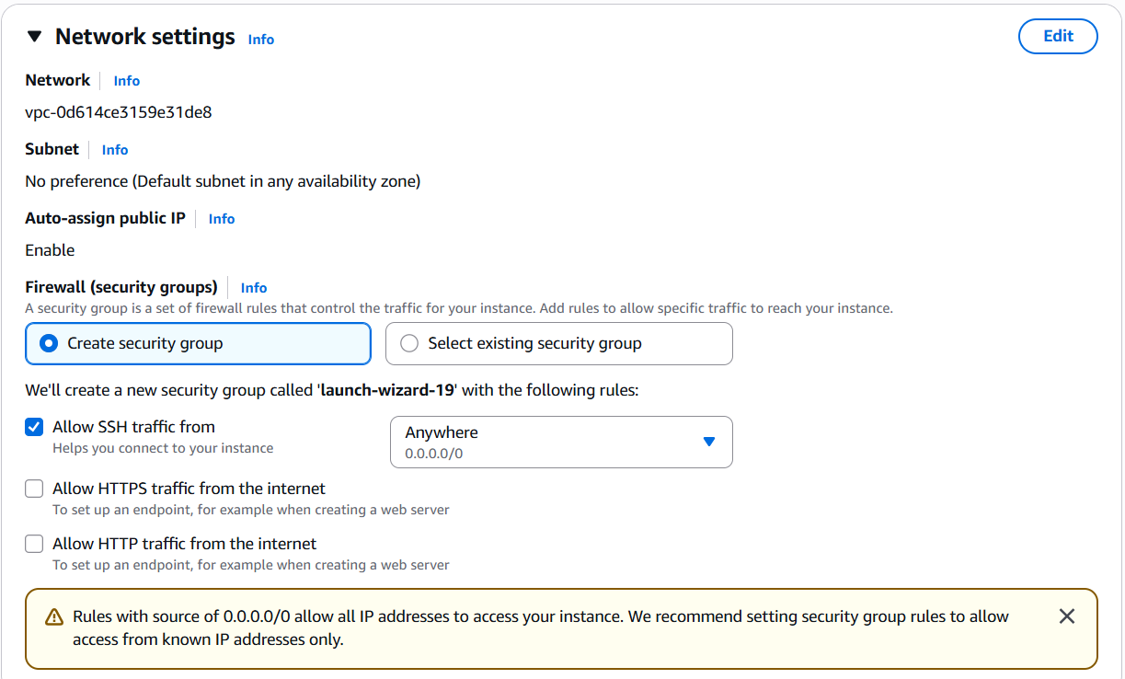

STEP11: configure storage for resource
- Check the configure storage it is process of arranging and managing storage resources like drives,disk and cloud service.
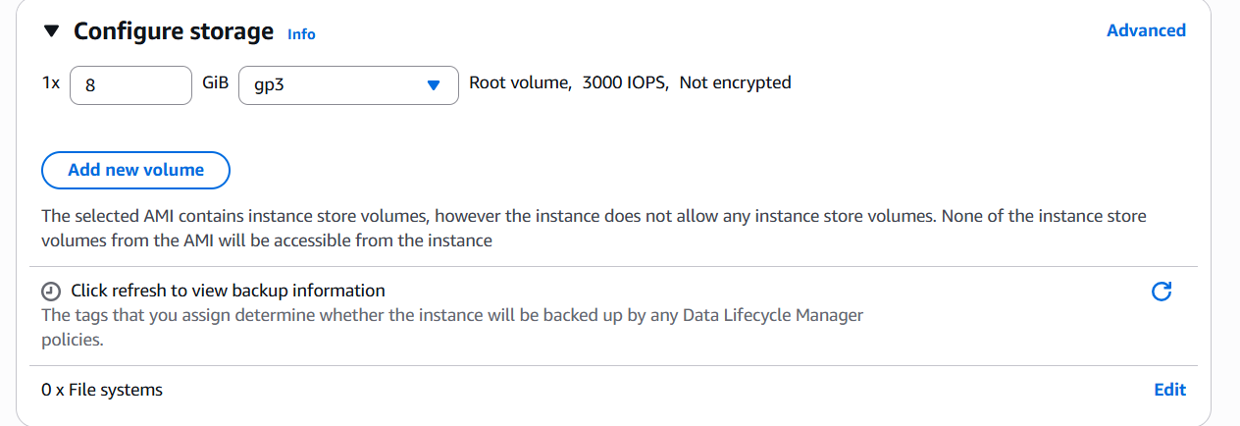
STEP 12: creation of pem file ppk file to access the server
- After that go to down page you can see the key pair then click on create new key pair
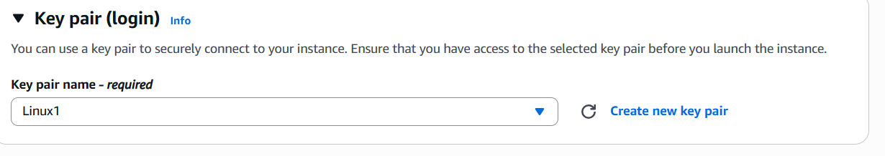STEP 13: create key pair
- we have to given any key pair name then click on create key pair
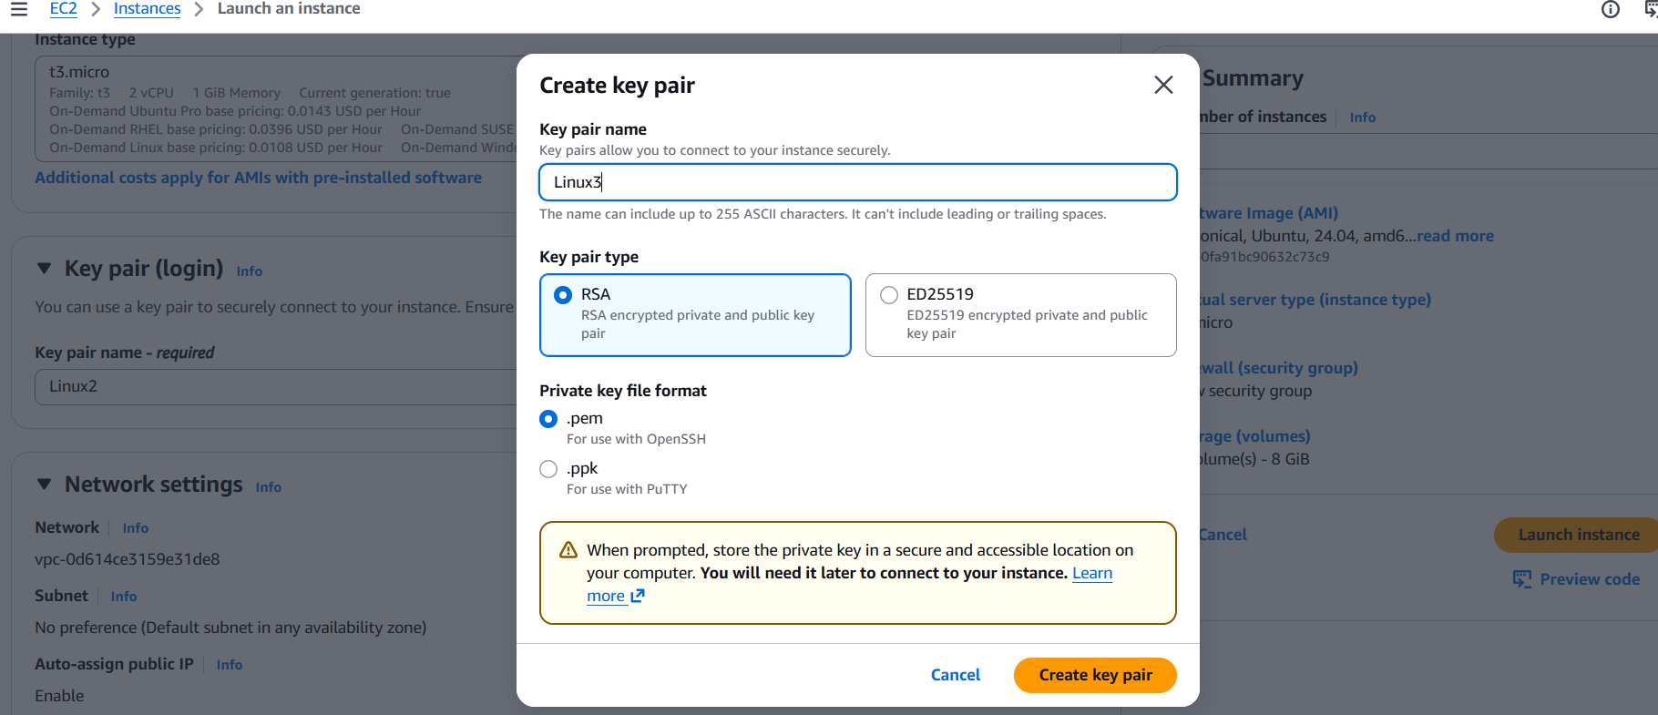

STEP14: Successful download key pair
- After creating a key pair it will download the key pair in flies then we have to open our key pair
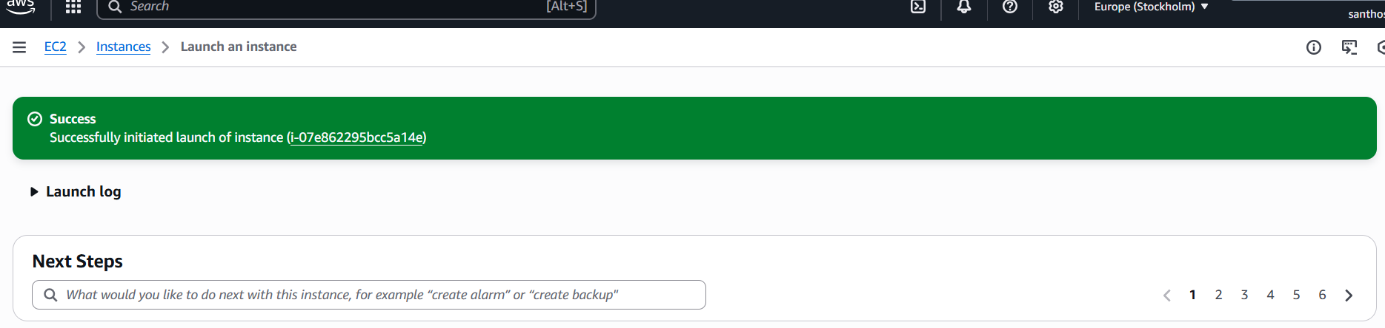
Step 15 : Then after we have click on Dashbaord
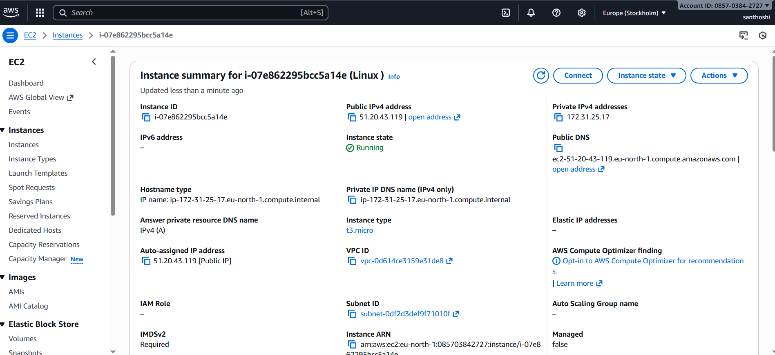Step 16: Launch Instances
Then after the dashboard will open then click on launch Instances
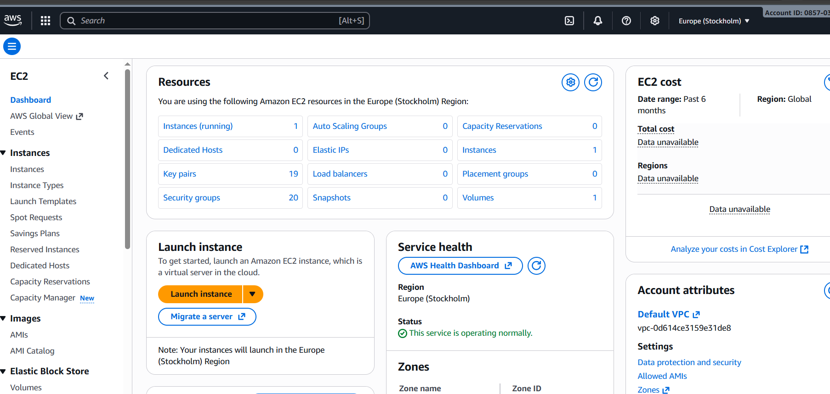
Step 17: server connect
- we have to connect to the our server then click on connect
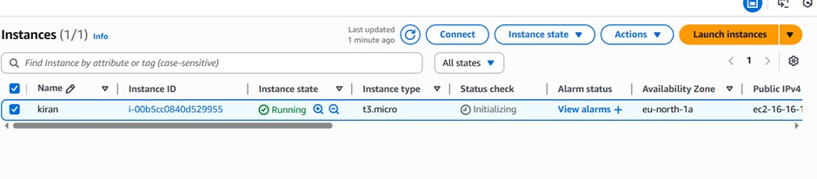Step 18: SSH CLIENT
- we have to select the SSH client then click on connect here SSH is (secure shell) it was a network protocol
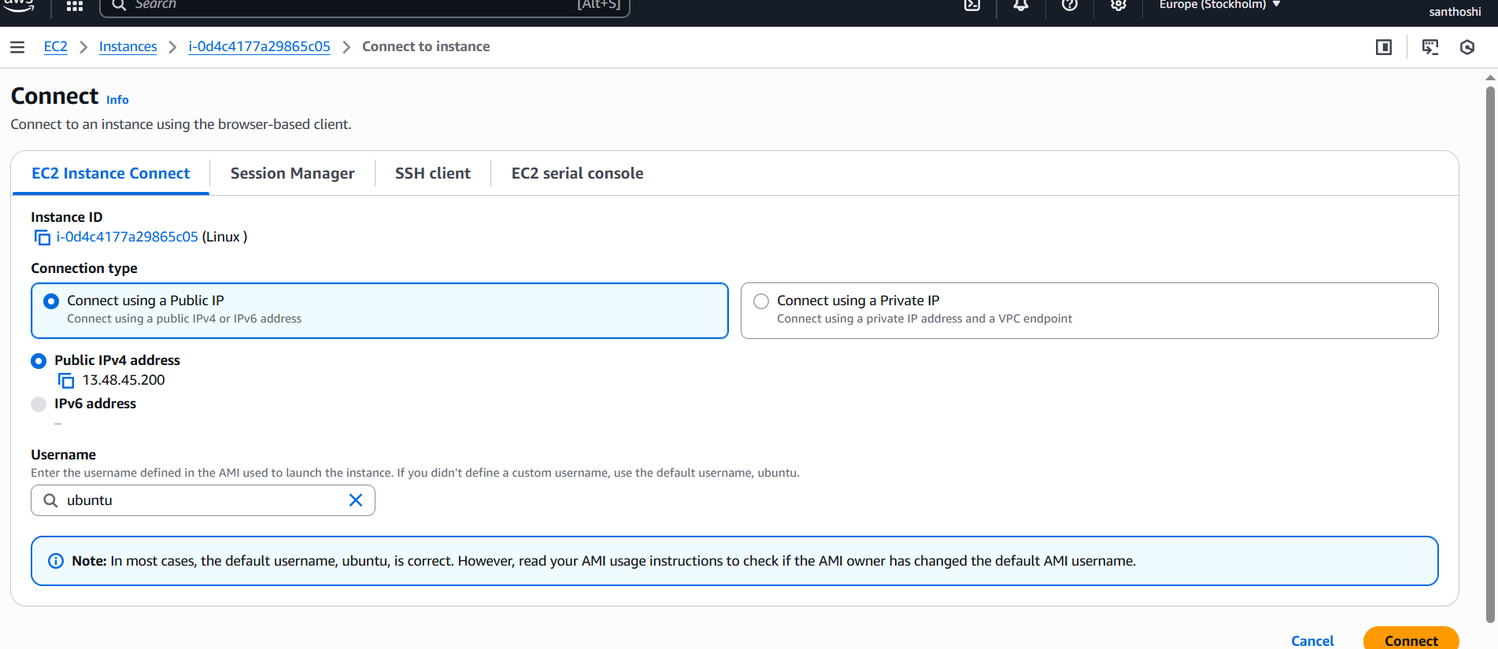.
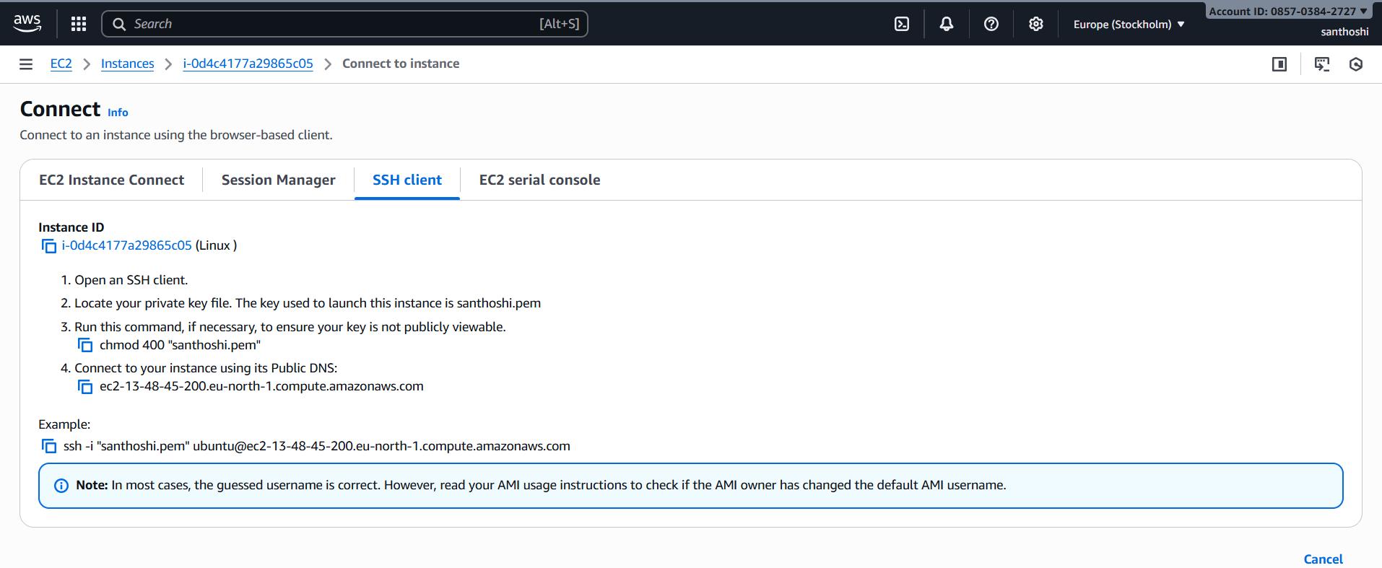

Step 19: Windows power shell
After that click on the windows power shell here it is cross plantform task automation solutions made up of a command line shell , a scripting language, and a configuration management framework , power shell works on windows and linux
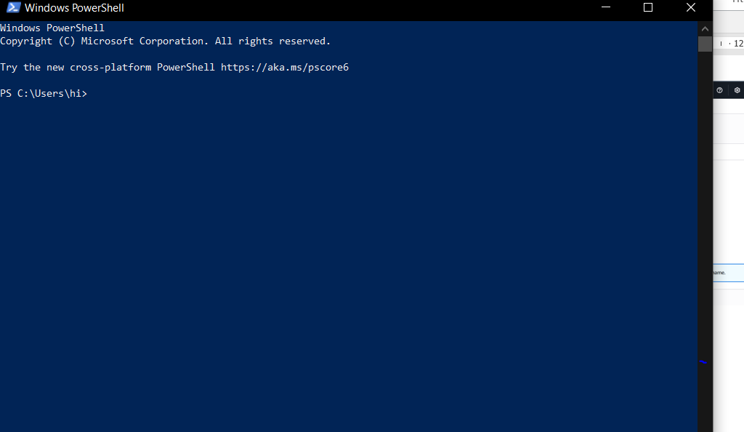
STEP 20: Type PWD
Then type pwd here pwd is (present working directory)
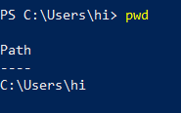

STEP 21: Again type (ls ) it will go to list of directory then are present on our flies
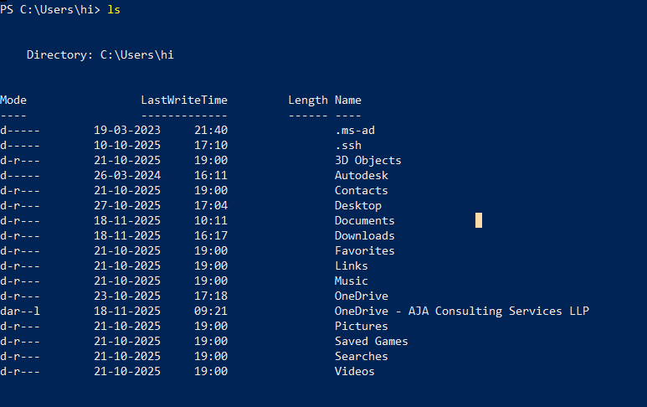
STEP 22: After that we have type the command cd ./Downloads/
STEP 23: we will go downlode the type the command as ls.\Linux3.prem
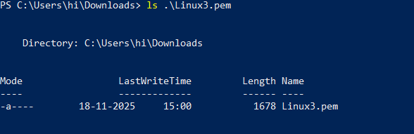

STEP24 : After that we have to go to our conncted instances the copy our full ssh command as (ssh -i "Linux3.pem" ubuntu@ec2-51-20-43-119.eu-north-1.compute.amazonaws.com) then click on enter while running the command it will say are you sure you want to continue to connect the we have type as yes it will run the command and we will go to Ubuntu ck
